**INFORMATION**

**NAME: Narendra Kumar Uchaniya**

**PASSPORT SIZE PIC:** 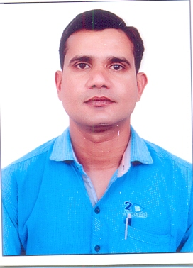

**Highest Qualification: Graduation and Diploma in Electrical Engineering,**

**Diploma in Computer Application**

**Designation: Lab Instructor**

**LAB No. Assigned: CP 8**

**Email Id: narendrauchaniya.ee@jecrc.ac.in**

**Experience: 10 Year**